Brent Schoenmakers & Cihan Kurt

IPv6 Assignment

Task 2:

Provide adjusted network drawing with the configured interfaces.

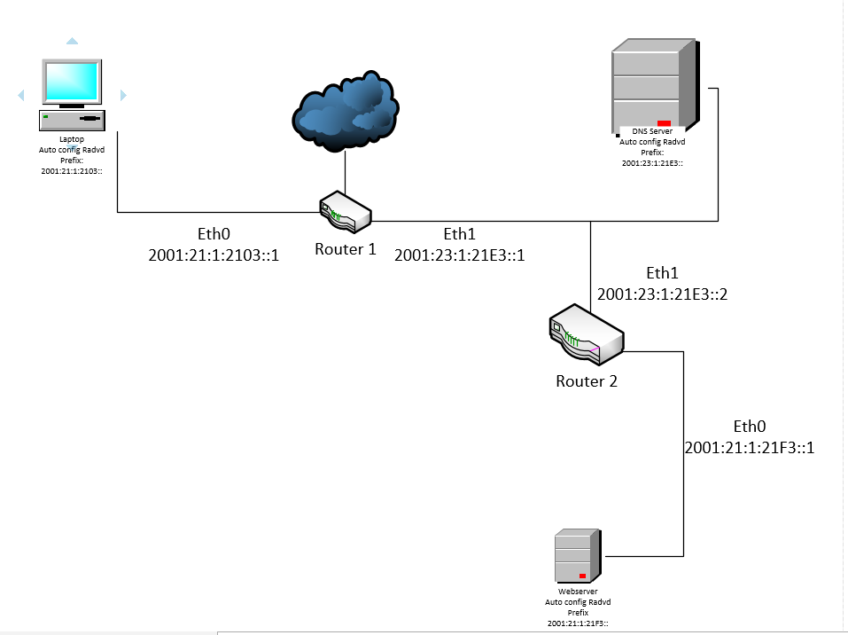

For each of the 3 subnetworks provide a screenshot for a successful ping between two nodes of the subnetwork.

**Laptop to eth0 of Router1:**

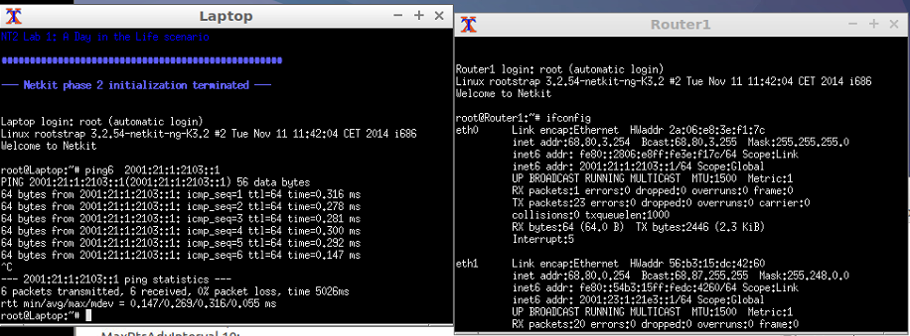

**Dns to eth1 of Router2:**

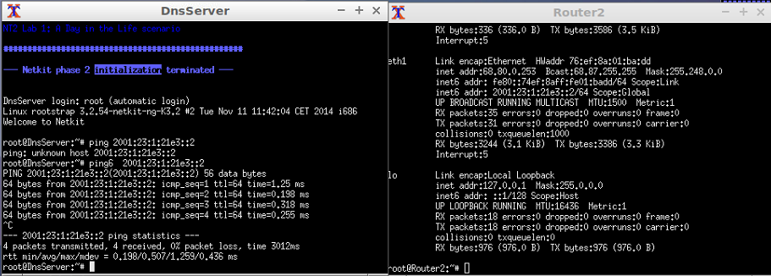

**Webserver to eth0 of Router2:**

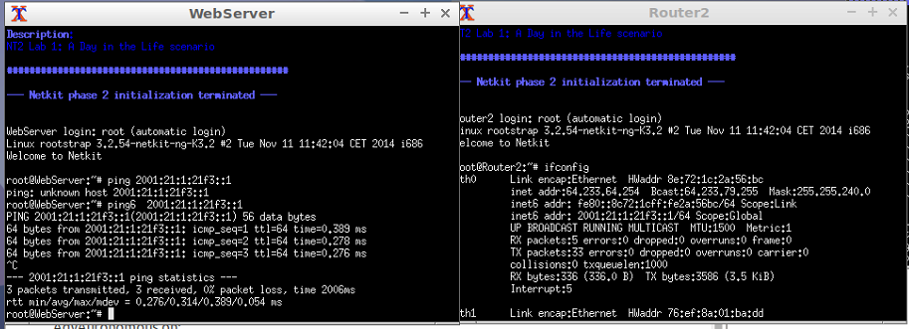

Task 3:

**Provide screenshots of the following successful IPv6 pings:**

1. ***Laptop* to *WebServer***

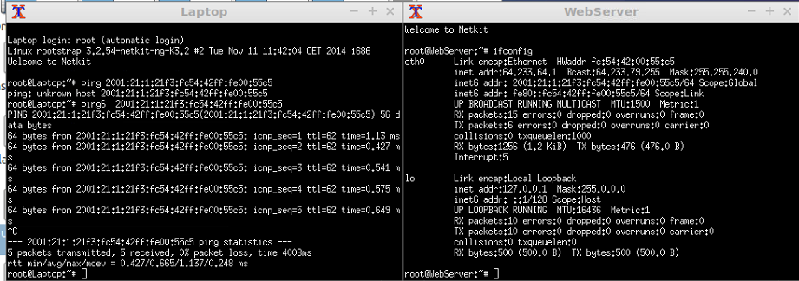

1. ***DnsServer* to *Laptop***

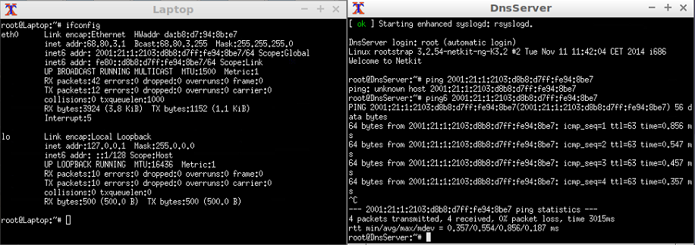

1. ***DnsServer* to WebServer**

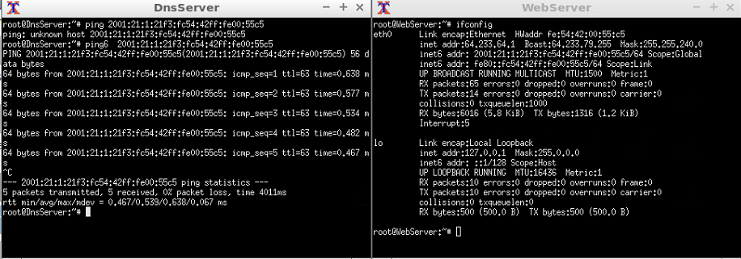

**Explain how your automatic IPv6 addresses were formed based on one example autoconfigured IPv6 address.**

in the radvd.conf file, we gave every eth interface a network prefix like the following radvd.conf file that is located in the router1 folder:

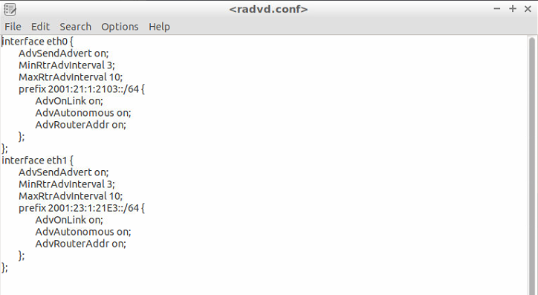

The interface eth0 got the laptop network prefix, and the eth1 got the dns server prefix. By doing this, laptop and dns server got an automatic assigned ipv6 address because of radvd. In the interfaces of laptop and dnsserver we had to add the following line to make them able to get an automatic ipv6 address:



We also did the same thing in router2. This router has a different radvd.conf file:

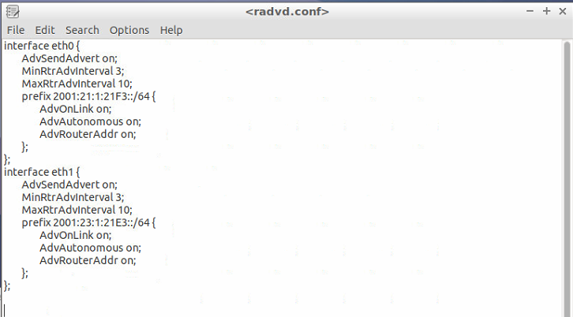

The interface eth0 got the webserver network prefix, and the eth1 got the dns server prefix. By doing this, webserver and dns server got an automatic assigned ipv6 address because of radvd. We chose to auto assign the dns server again here, to eliminate the need of choosing what you have to boot first. In the interfaces of webserver and dnsserver we had to add the following line to make them able to get an automatic ipv6 address:

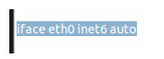

Task 4:

1. Why don’t we need ARP in IPv6 anymore ?

ARP uses MAC-Addresses to know to which host in a specific network it should send a package.   
IPv4 addresses were translated to MAC-addresses because there were some IPv4 addresses that could be used multiple times. Using the translated MAC-address, the computer knew where exactly to send the package to.

With IPv6, this is not needed, because there is no such thing as IPv6 addresses that could be used multiple times. There are simply enough IPv6 addresses for that to not be an issue. Because of this, ARP is not needed if you are using IPv6.

1. What is the difference between Stateful and Stateless DHCPv6 ?

A **Stateful** address assignment involves someone keeping track of the State. Which is to say, some system exists that provides a log that certain IP addresses were assigned to certain MAC addresses. DHCP / DHCPv6 keeps truck of such information.

A **Stateless** address assignment does not keep track of what has or hasn't been assigned. It simply determines what address it should use on a particular network.

In short,  **Stateful** requires a DHCP server to have been configured to hand out addresses. While **Stateless** address assignment simply requires the Router/Default-Gateway to understand and implement  [RFC 4862](https://tools.ietf.org/html/rfc4862)(This means stateless address autoconfiguration).